**Question 1: Pseudocode Development - Task: Write a detailed pseudocode for a simple program that takes a number as input, calculates the square if it's even or the cube if it's odd, and then outputs the result. Incorporate conditional and looping constructs.**

Answer-1

// --

Pseudocode --//

Start

initialise n=0, read input=n

if n is even

square = n*n

print square value

else n is odd

cube = n*n*n

print cube value

End

**Question 2: Flowchart Creation - Design a flowchart that outlines the logic for a user login process. It should include conditional paths for successful and unsuccessful login attempts, and a loop that allows a user three attempts before locking the account**

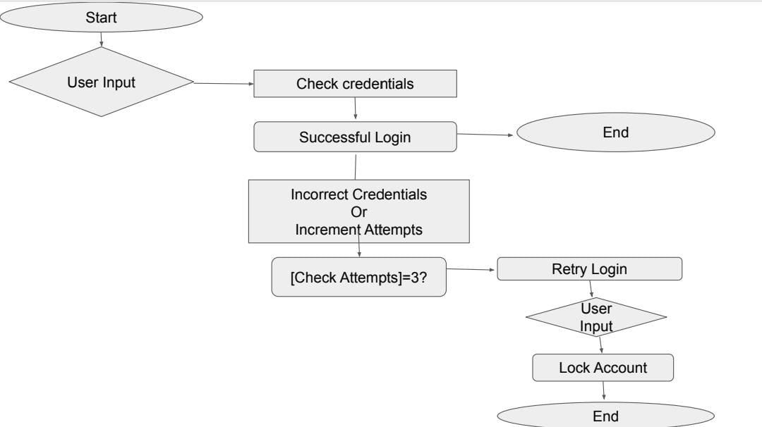

**Assignment 3: Function Design and Modularization - Create a document that describes the design of two modular functions: one that returns the factorial of a number, and another that calculates the nth Fibonacci number. Include pseudocode and a brief explanation of how modularity in programming helps with code reuse and organization.**

/--fibonacci--/

function fibonacci (n)

if n=0

return 0

else if n=1

return 1

else :

return f(n-1)+f(n-2)

/--factorial--/

function factorial(n)

if n=0

return 1

else

return n*f(n-1)